**English**

**Course**: 1st year

**Date**: March, 27th

**Teacher**: Nátali Gómez

**Student**:

**Countries**

1. **Look and unscramble the names of the countries.**

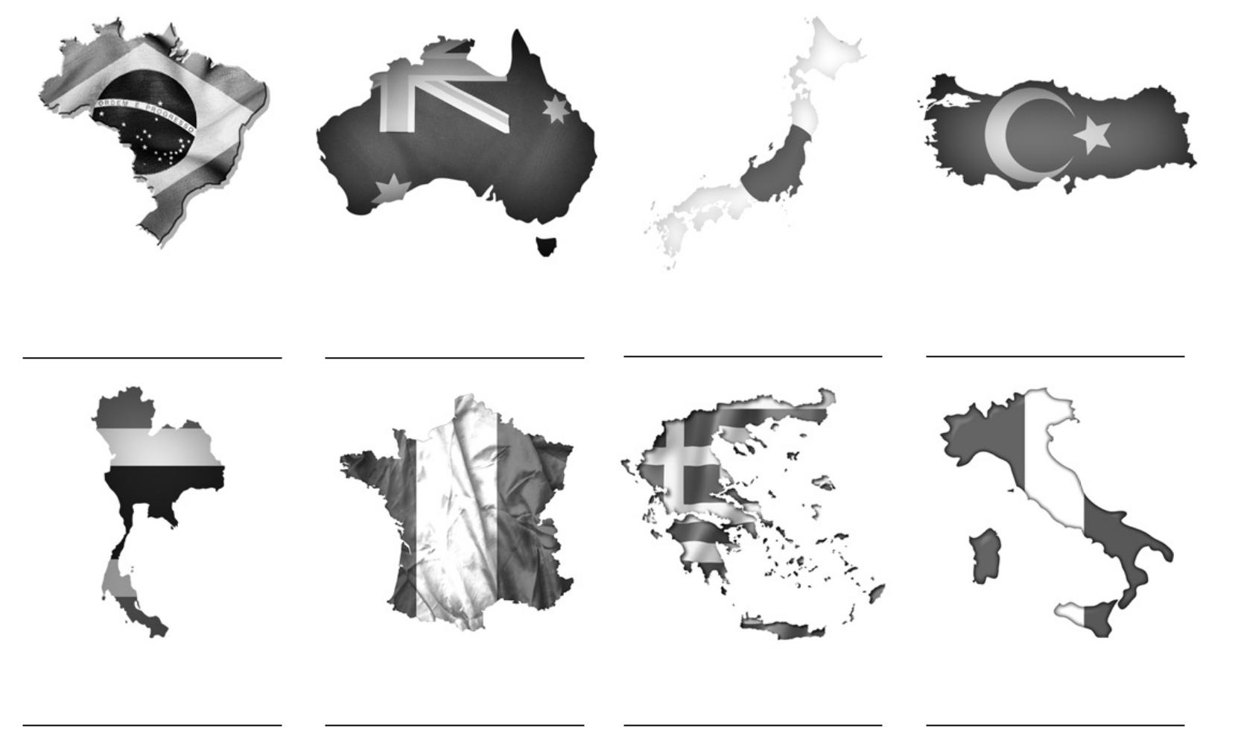

r i l a b z a t i a s u r a l n a j a p k u r t e y

Brazil

h a l i n t a d c a r f e n e g r e c e t y i a l

1. **Look, write and number.**

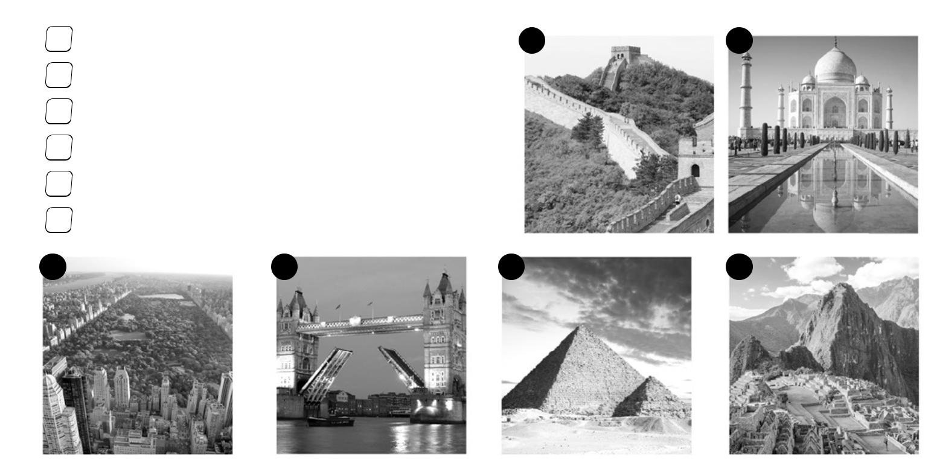

|  |  |  |  |  |  |  |  |  |  |  |  |  |
| --- | --- | --- | --- | --- | --- | --- | --- | --- | --- | --- | --- | --- |
| 1 The Great Wall is in | | | | |  | China |  | | | | . **1** | **2** |
|  | Tower Bridge is in | |  | | |  | . | | | |  |  |
|  | Machu Picchu is in | |  |  | |  |  | |  | . |  |  |
|  | The Taj Mahal is in | | |  | |  | . | | | |  |  |
|  | Central Park is in |  | |  | |  |  | . |  |  |  |  |
|  | The Great Pyramid is in | | | | |  |  |  |  |  |  | . |
| **3** | **4** | | | | |  | **5** | | | | | **6** |

**The verb *to be***

**Affirmative** forms of the verb *to be* (forma afirmativa*)*

|  |  |  |
| --- | --- | --- |
| **Subject Pronouns** | **Full Form** | **Contracted Form** |
| I | am | 'm |
| you | are | 're |
| he/she/it | is | 's |
| we | are | 're |
| you | are | 're |
| they | are | 're |

Interrogative forms of the verb to be (forma interrogativa):

|  |  |
| --- | --- |
| Am | I? |
| Are | you? |
| Is | he/she/it? |
| Are | we? |
| Are | you? |
| Are | they? |

Negative Forms of the verb to be (forma negativa):

|  |  |  |
| --- | --- | --- |
| **Subject Pronouns** | **Full Form** | **Contracted Form** |
| I | am not | 'm not |
| you | are not | aren't |
| he/she/it | is not | isn't |
| we | are not | aren't |
| you | are not | aren't |
| they | are not | aren't |

**Examples**:

* **Is** Brad Pitt French?
* No, he **isn't**. He**'s** American.
* What about Angelina Joli? **Is** she American, too?
* Yes, she **is**. She **is** American.
* **Are** brad Pitt and Angelina Joli French?
* No, They **aren't**. They **are** American.

Use of the simple present of **to be** (ser/estar)

The principal use of the simple present is to refer to an action or event that takes place habitually (una acción o evento que ocurre habitualmente, siempre), but with the verb "to be" the simple present tense also refers to a present or general state, whether temporary, permanent or habitual (o un estado permanente o habitual).

* I **am** happy.
* She **is** helpful.

The verb to be in the simple present can be also used to refer to something that is true at the present moment (algo que es verdad).

* She **is** 20 years old.
* He **is** a student.

**Remember**:

* **'m, 're, 's** are short (contracted) forms of  **am, are, is**
* **'m not, aren't, isn't** are short (contracted forms) of **am not, are not, is not.**

**Verb *be***

1. **Read and complete.**

|  |  |  |  |  |  |  |  |  |  |  |  |  |  |
| --- | --- | --- | --- | --- | --- | --- | --- | --- | --- | --- | --- | --- | --- |
| 1. you + are = you’re | | | |  | 4. she + | |  |  |  |  | = she’s | | |
| 2. |  | + is = he’s | | | 5. I + am = | | |  |  |  |  |  |  |
| 3. we + are = | | |  |  | 6. |  |  |  | + |  |  |  | = they’re |

1. 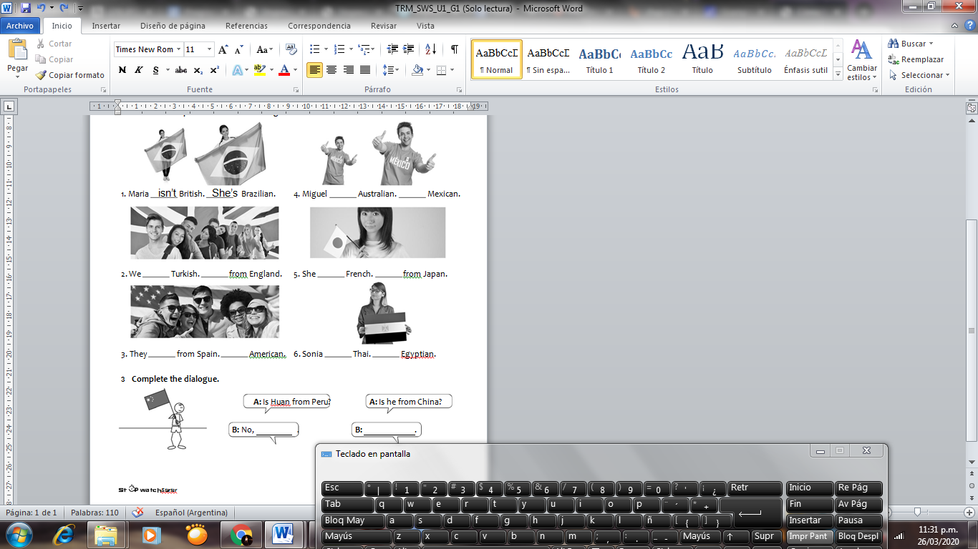**Look and complete the sentences using contractions.**

Buenas chicos, espero estén bien. Las resoluciones de estas actividades inclúyanlas acá, y espero las respuestas de lo enviado la semana pasada.

Gracias.